.for 2 hours also an hour for social entertainment.
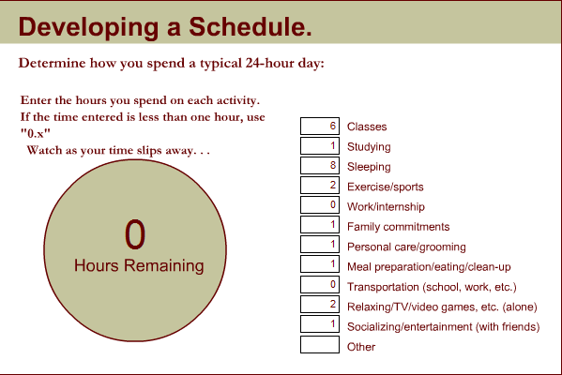
I wake up every day in the weekdays at 7:45 and ready up for school. I go to school for about 6 hours and go home and study for an hour. I sleep for eight hours and play sports for 2 hours. I do family commitments for an hour, personal care for about an hour meal preparation for an hour as well as relaxing.

